WP Lab 3 – JavaScript

Q1 - Write a JavaScript program to perform an online quiz

Code -

<!DOCTYPE html>
<html lang="en">
<head>
<meta charset="UTF-8">
<meta name="viewport" content="width=device-width, initial-scale=1.0">
<title>Online Quiz</title>
<style>
body {
font-family: Arial, sans-serif;
max-width: 600px;
margin: 0 auto;
padding: 20px;
}
#quiz {
background-color: #f0f0f0;
padding: 20px;
border-radius: 10px;
}
h1 {
text-align: center; /* Center the title */
}
button {
margin-top: 10px;
padding: 10px 20px;
font-size: 16px;
background-color: #4CAF50;
color: white;
border: none;
border-radius: 5px;
cursor: pointer;
}
button:hover {
background-color: #45a049;
}
.result {
margin-top: 20px;
}
.correct {
color: green;
}
.wrong {
color: red;
}
</style>
</head>
<body>
<div id="quiz">
<h1>Online Quiz</h1>
<div id="questions"></div>
<button id="submit">Submit</button>
<button id="restart" style="display: none;">Restart</button>
<div id="result" class="result"></div>
</div>

<script>
const quizData = [
{
question: "What is the largest mammal in the world?",
choices: ["Elephant", "Blue Whale", "Giraffe", "Great White Shark"],
correct: 1
},
{
question: "What is the chemical symbol for gold?",
choices: ["Au", "Ag", "Fe", "Pb"],
correct: 0
},
{
question: "Which country is known as the Land of the Rising Sun?",
choices: ["China", "Japan", "Thailand", "South Korea"],
correct: 1
},
{
question: "What is the capital city of Australia?",
choices: ["Sydney", "Melbourne", "Canberra", "Brisbane"],
correct: 2
},
{
question: "Which planet is known for its rings?",
choices: ["Earth", "Mars", "Saturn", "Jupiter"],
correct: 2
}
];

let score = 0;
const questionsEl = document.getElementById("questions");
const submitBtn = document.getElementById("submit");
const restartBtn = document.getElementById("restart");
const resultEl = document.getElementById("result");

function loadQuestions() {
questionsEl.innerHTML = "";
quizData.forEach((question, index) => {
questionsEl.innerHTML += `
<div>
<h3>${index + 1}. ${question.question}</h3>
${question.choices.map((choice, i) => `
<div>
<input type="radio" id="q${index}c${i}" name="q${index}" value="${i}">
<label for="q${index}c${i}">${choice}</label>
</div>
`).join('')}
</div>
`;
});
}

function checkAnswers() {
score = 0;
let resultHTML = "";
quizData.forEach((question, index) => {
const selectedChoice = document.querySelector(`input[name="q${index}"]:checked`);
const answer = selectedChoice ? parseInt(selectedChoice.value) : null;
if (answer === question.correct) {
score++;
resultHTML += `<p class="correct">${question.question} - Correct!</p>`;
} else {
resultHTML += `<p class="wrong">${question.question} - Wrong! Correct answer: ${question.choices[question.correct]}</p>`;
}
});
resultEl.innerHTML = `You scored ${score} out of ${quizData.length}!<br>${resultHTML}`;
submitBtn.style.display = "none";
restartBtn.style.display = "inline";
}

function restartQuiz() {
loadQuestions();
resultEl.innerHTML = "";
submitBtn.style.display = "inline";
restartBtn.style.display = "none";
}

submitBtn.addEventListener("click", checkAnswers);
restartBtn.addEventListener("click", restartQuiz);
loadQuestions();
</script>
</body>
</html>

Output -
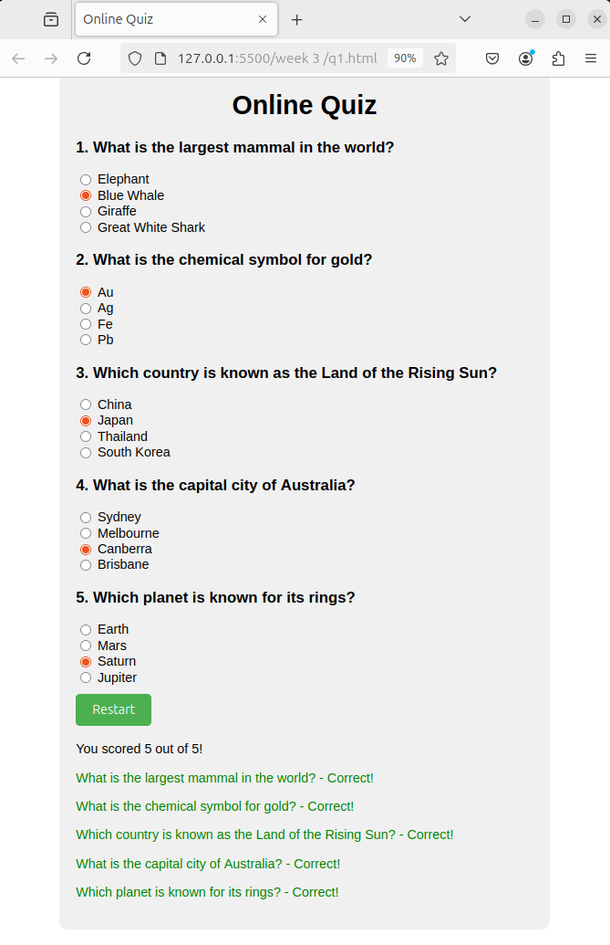

Q2 - Write a JavaScript program to Wish a user at different hours of a day. Use
appropriate dialog boxes for wishing the user. Display the dynamic clock on the
web page. Make use of CSS and HTML5 elements for creative and attractive
design.

Code -

<!DOCTYPE html>
<html lang="en">
<head>
<meta charset="UTF-8">
<meta name="viewport" content="width=device-width, initial-scale=1.0">
<title>Dynamic Greeting</title>
<style>
@import url('https://fonts.googleapis.com/css2?family=Poppins:wght@300;400;600&display=swap');

body {
font-family: 'Poppins', sans-serif;
background: linear-gradient(135deg, #667eea 0%, #764ba2 100%);
color: #ffffff;
display: flex;
justify-content: center;
align-items: center;
height: 100vh;
margin: 0;
overflow: hidden;
}

.container {
text-align: center;
background-color: rgba(255, 255, 255, 0.1);
backdrop-filter: blur(10px);
border-radius: 20px;
padding: 40px;
box-shadow: 0 8px 32px rgba(31, 38, 135, 0.37);
border: 1px solid rgba(255, 255, 255, 0.18);
transition: transform 0.3s ease;
}

.container:hover {
transform: translateY(-5px);
}

h1 {
font-size: 2.5em;
margin-bottom: 20px;
font-weight: 600;
}

.clock {
font-size: 4em;
margin: 30px 0;
font-weight: 300;
text-shadow: 2px 2px 4px rgba(0, 0, 0, 0.1);
}

button {
padding: 12px 24px;
font-size: 1.2em;
color: #ffffff;
background-color: #4CAF50;
border: none;
border-radius: 50px;
cursor: pointer;
transition: all 0.3s ease;
box-shadow: 0 4px 6px rgba(0, 0, 0, 0.1);
}

button:hover {
background-color: #45a049;
transform: translateY(-2px);
box-shadow: 0 6px 8px rgba(0, 0, 0, 0.15);
}

button:active {
transform: translateY(0);
box-shadow: 0 2px 4px rgba(0, 0, 0, 0.1);
}

@keyframes fadeIn {
from { opacity: 0; transform: translateY(-20px); }
to { opacity: 1; transform: translateY(0); }
}

.fade-in {
animation: fadeIn 0.5s ease-out;
}
</style>
</head>
<body>
<div class="container fade-in">
<h1>Welcome to the Dynamic Greeting App!</h1>
<div id="clock" class="clock"></div>
<button id="greetButton">Get Greeting</button>
</div>

<script>
function updateClock() {
const now = new Date();
const hours = now.getHours();
const minutes = now.getMinutes();
const seconds = now.getSeconds();
const timeString = `${String(hours).padStart(2, '0')}:${String(minutes).padStart(2, '0')}:${String(seconds).padStart(2, '0')}`;

document.getElementById('clock').textContent = timeString;
}

function greetUser() {
const now = new Date();
const hours = now.getHours();
let greeting;

if (hours < 12) {
greeting = "Good Morning!";
} else if (hours < 18) {
greeting = "Good Afternoon!";
} else {
greeting = "Good Evening!";
}

const greetingElement = document.createElement('div');
greetingElement.textContent = greeting;
greetingElement.style.position = 'fixed';
greetingElement.style.top = '20px';
greetingElement.style.left = '50%';
greetingElement.style.transform = 'translateX(-50%)';
greetingElement.style.padding = '10px 20px';
greetingElement.style.backgroundColor = 'rgba(255, 255, 255, 0.9)';
greetingElement.style.color = '#333';
greetingElement.style.borderRadius = '5px';
greetingElement.style.boxShadow = '0 2px 10px rgba(0, 0, 0, 0.1)';
greetingElement.style.zIndex = '1000';
greetingElement.classList.add('fade-in');

document.body.appendChild(greetingElement);

setTimeout(() => {
greetingElement.style.opacity = '0';
greetingElement.style.transition = 'opacity 0.5s ease-out';
setTimeout(() => {
document.body.removeChild(greetingElement);
}, 500);
}, 3000);
}

document.getElementById('greetButton').addEventListener('click', greetUser);
setInterval(updateClock, 1000);
updateClock(); // Initial call to display the clock immediately
</script>
</body>
</html>

Output -
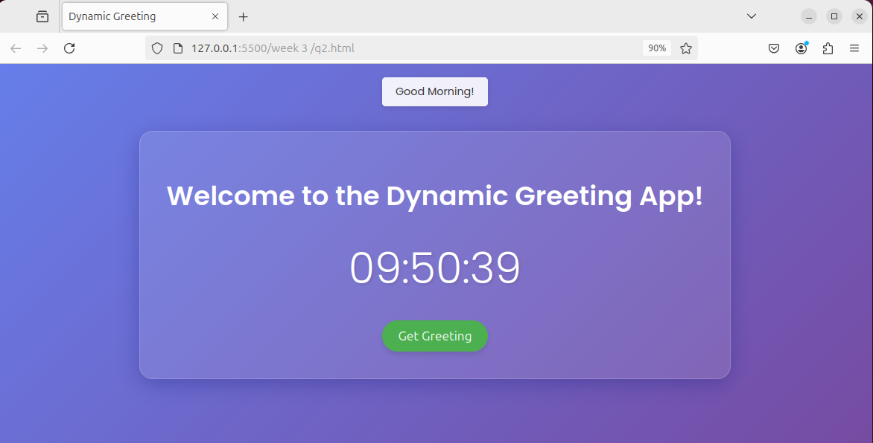

Q3 - Write the java script program to display the grade [A, B,C,D] based on the marks
entered by student(take the input into text boxes). Enter the marks of 4 subjects and
calculate the average( using button). If the avg>90 then A, avg>80 then B, if avg>70
then C, if avg>60 then D.

Code -

<!DOCTYPE html>
<html lang="en">
<head>
<meta charset="UTF-8">
<meta name="viewport" content="width=device-width, initial-scale=1.0">
<title>Grade Calculator</title>
<style>
body {
font-family: 'Poppins', sans-serif;
background: linear-gradient(135deg, #667eea 0%, #764ba2 100%);
color: #333;
display: flex;
justify-content: center;
align-items: center;
height: 100vh;
margin: 0;
}
.container {
background-color: rgba(255, 255, 255, 0.9);
border-radius: 10px;
padding: 30px;
box-shadow: 0 5px 15px rgba(0, 0, 0, 0.2);
width: 300px;
text-align: center;
}
h1{
margin-bottom: 20px;
}
input[type="number"] {
width: 100%;
padding: 10px;
margin: 10px 0;
border: 1px solid #ddd;
border-radius: 5px;
font-size: 16px;
}
button{
padding: 10px 20px;
font-size: 16px;
color: white;
background: #667eea;
border: none;
border-radius: 5px;
cursor: pointer;
margin-top: 10px;
}
button:hover {
background: #764ba2;
}
.result {
margin-top: 20px;
font-size: 18px;
font-weight: bold;
}
</style>
</head>
<body>
<div class="container">
<h1>Grade Calculator</h1>
<input type="number" id="subject1" placeholder="Subject 1 Marks" required>
<input type="number" id="subject2" placeholder="Subject 2 Marks" required>
<input type="number" id="subject3" placeholder="Subject 3 Marks" required>
<input type="number" id="subject4" placeholder="Subject 4 Marks" required>
<button id="calculateButton">Calculate Grade</button>
<div class="result" id="result"></div>
</div>
<script>
document.getElementById('calculateButton').addEventListener('click', function() {
const marks = [
parseFloat(document.getElementById('subject1').value),
parseFloat(document.getElementById('subject2').value),
parseFloat(document.getElementById('subject3').value),
parseFloat(document.getElementById('subject4').value)
];
if (marks.some(isNaN)) {
alert('Please enter valid marks for all subjects.');
return;
}
const average = marks.reduce((a, b) => a + b, 0) / marks.length;
let grade;
if (average > 90) grade = 'A';
else if (average > 80) grade = 'B';
else if (average > 70) grade = 'C';
else if (average > 60) grade = 'D';
else grade = 'F';
document.getElementById('result').textContent = `Average: ${average.toFixed(2)}, Grade: ${grade}`;
});
</script>
</body>
</html>

Output -

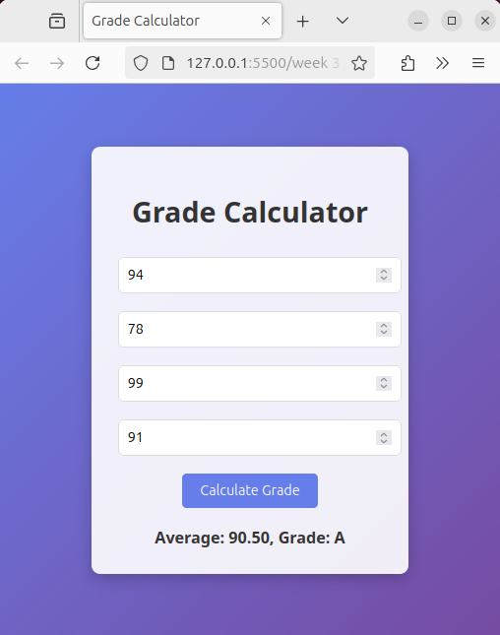
Q4 - Write the JavaScript program to show the below output.
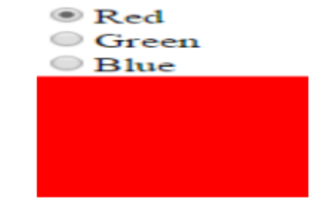

Code -

<!DOCTYPE html>
<html lang="en">
<head>
<meta charset="UTF-8">
<meta name="viewport" content="width=device-width, initial-scale=1.0">
<title>Color Selector</title>
<style>
body {
font-family: Arial, sans-serif;
display: flex;
justify-content: center;
align-items: center;
height: 100vh;
margin: 0;
background-color: #f0f0f0;
}
.container {
background: white;
padding: 30px;
border-radius: 10px;
box-shadow: 0 2px 10px rgba(0, 0, 0, 0.1);
}
.color-option {
display: flex;
align-items: center;
margin: 10px 0;
}
input[type="radio"] {
appearance: none;
width: 20px;
height: 20px;
border: 2px solid #ccc;
border-radius: 50%;
margin-right: 10px;
cursor: pointer;
position: relative;
}
input[type="radio"]:checked::after {
content: '';
position: absolute;
width: 12px;
height: 12px;
background: #666;
border-radius: 50%;
top: 50%;
left: 50%;
transform: translate(-50%, -50%);
}
.color-display {
width: 300px;
height: 150px;
border: 2px solid #ccc;
transition: background-color 0.3s;
background-color: red; /* Set initial color */
}
</style>
</head>
<body>
<div class="container">
<div>
<div class="color-option">
<input type="radio" id="red" name="color" value="red" checked>
<label for="red">Red</label>
</div>
<div class="color-option">
<input type="radio" id="green" name="color" value="green">
<label for="green">Green</label>
</div>
<div class="color-option">
<input type="radio" id="blue" name="color" value="blue">
<label for="blue">Blue</label>
</div>
</div>
<div class="color-display" id="colorDisplay"></div>
</div>

<script>
document.querySelectorAll('input[type="radio"]').forEach(radio => {
radio.addEventListener('change', (e) => {
document.getElementById('colorDisplay').style.backgroundColor = e.target.value;
});
});
</script>
</body>
</html>

Output -

